SALESFORCE TO WHATSAPP INTEGRATION

Resister as meta developer (google search🡪WhatsApp business platform cloud api)

Create App for WhatsApp (access token, phoneId)

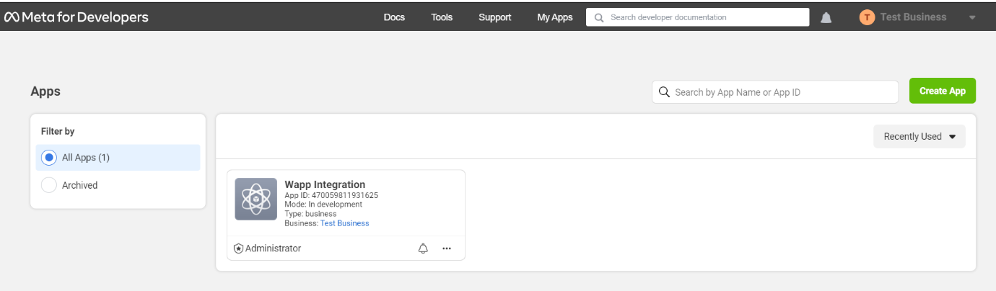

configure webhook (call-back URL, verify token, developer.facebook.com...)

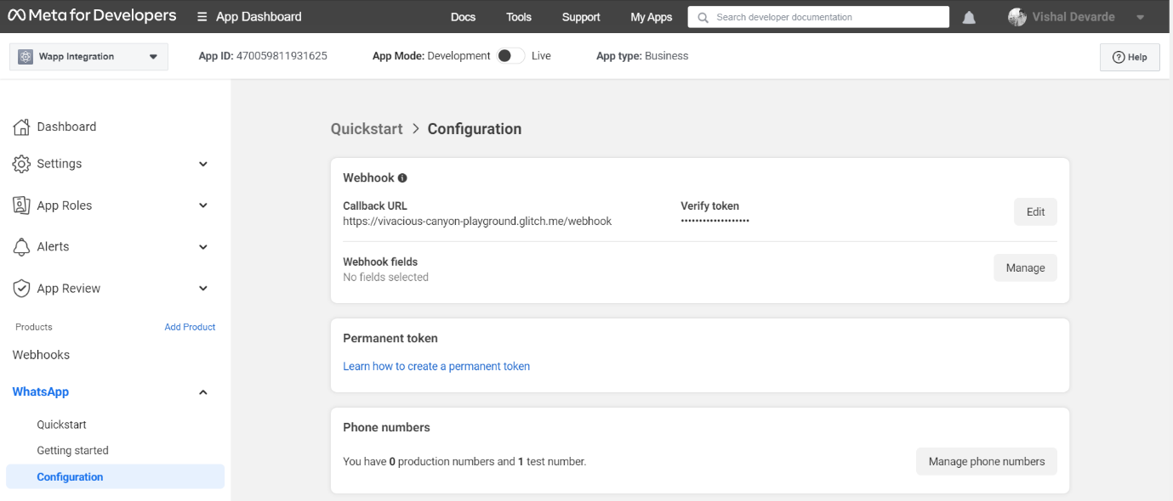

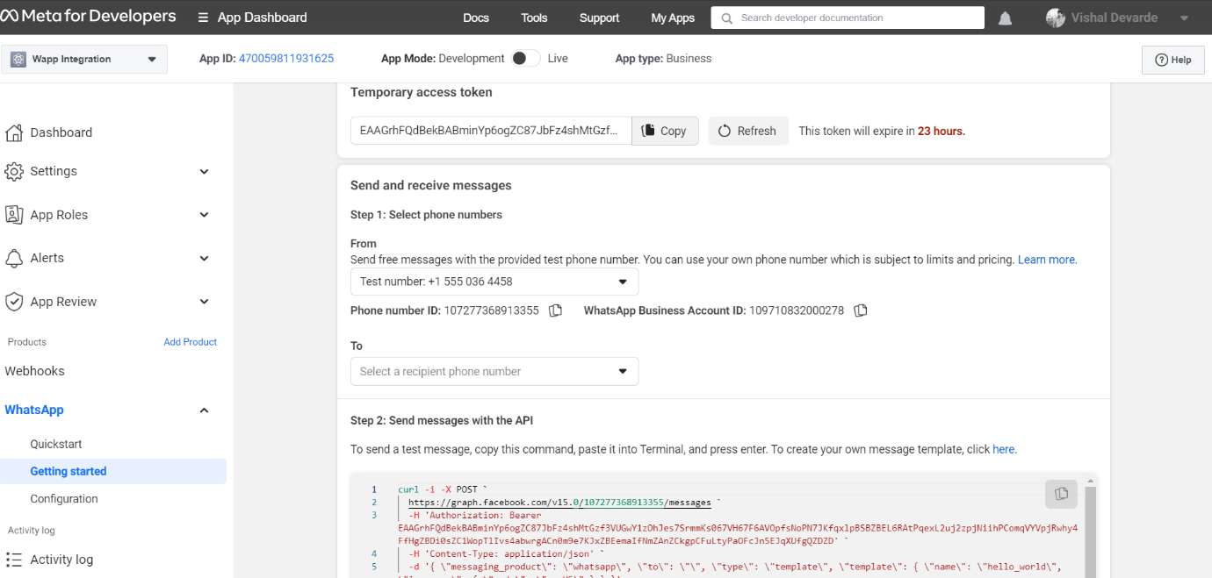

Now we have Endpoint, Body, Header

Create Remote site setting.

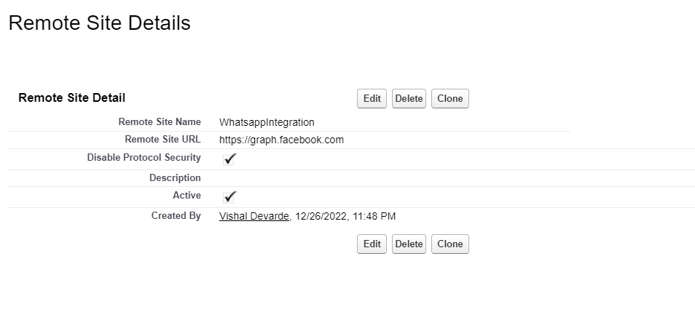

Create Apex callout

Create Lwc button

